Glomerella leaf spot
Phillip M. Brannen, University of Georgia, 2026

Description
Glomerella leaf spot (GLS) is a destructive fungal disease of apple foliage and fruit caused by various species of the genus Colletotrichum. On foliage, symptoms begin as small purple specks that expand into irregular necrotic spots or tan-to-brown blotches. As the disease progresses, infected leaves develop chlorosis and abscise prematurely, often leading to severe defoliation (Fig. 1). On fruit, GLS typically appears as small (1–4 mm) circular brown spots. These lesions are generally shallow and lack the conspicuous orange masses of conidia characteristic of bitter rot, though they may expand into rot after the fruit ripens.
Biology
The disease is caused by several species within the Colletotrichum gloeosporioides and C. acutatum species complexes. In Georgia, C. fructicola is the dominant causal agent (86%), followed by C. chrysophilum (10%). The pathogen produces both conidia (asexual) and ascospores (sexual) from leaf lesions, which serve as secondary inoculum and are dispersed by wind and rain splash. GLS has an extremely short latent period of only two days under optimal conditions, enabling rapid, multiple infection cycles throughout the summer. The fungus overwinters in fallen leaf litter, dormant buds, and twigs, providing primary inoculum for the following spring.
Host susceptibility is highly cultivar-specific and often linked to ‘Golden Delicious’ heritage. Highly susceptible cultivars include ‘Gala’, ‘Pink Lady’, ‘Golden Smoothee’, and ‘Granny Smith’. Conversely, cultivars such as ‘Fuji’ and ‘Red Delicious’ are completely resistant, a trait controlled by a single recessive gene.
Damage
GLS is a major economic threat in the southeastern USA, where it has recently emerged as one of the most damaging apple diseases. If left unmanaged, the disease can cause more than 75% defoliation by harvest. This premature leaf loss severely compromises tree health, shortens the tree's lifespan, and significantly reduces yields in the following season. Fruit infections, though often shallow, reduce the crop's aesthetic quality and marketability. In 2022 alone, the combined impact of bitter rot and GLS in Georgia was estimated at $3.6 million.
Management
Management of GLS requires an intensive, integrated approach. Growers must utilize a combination of multi-site protectants (e.g., captan and mancozeb) and single-site systemic fungicides. Due to the pathogen's rapid spread, shortened spray intervals of 7–10 days are often necessary for adequate control.
Widespread resistance to Quinone outside Inhibitor (QoI) fungicides (FRAC 11) has been documented in Georgia, driven by the G143A mutation. This mutation is present in nearly all C. fructicola isolates, so QoIs (such as pyraclostrobin) may provide little to no control.
Orchard sanitation is recommended to reduce primary inoculum. This includes removing fallen fruit and leaf litter, shredding debris with a flail mower, and applying urea to accelerate decomposition during winter. With that said, recent research has not necessarily supported that inoculum reduction has a substantial impact on GLS, though it is generally important and recommended for other apple diseases. Planting resistant cultivars such as ‘Fuji’ is the most effective long-term management strategy.

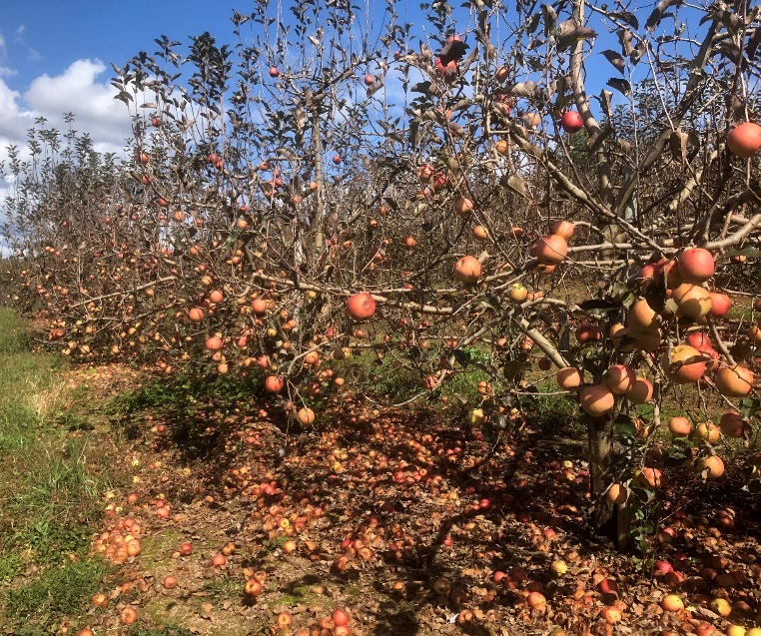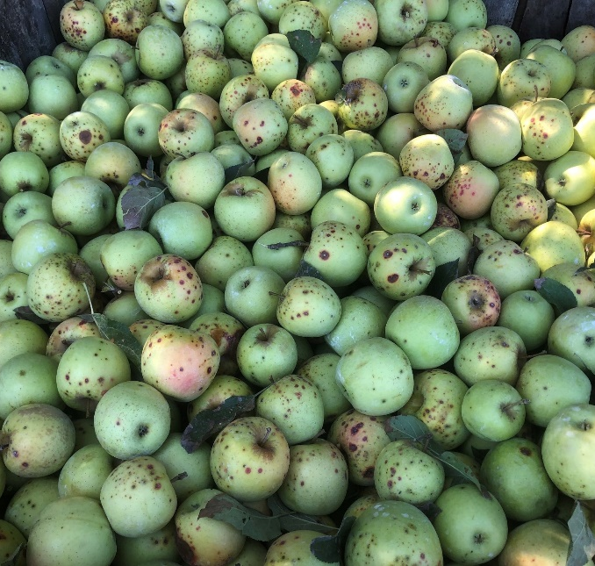
B
A
Figure 1. Symptoms of Glomerella leaf spot: A. Defoliation affecting a row of ‘Gala’ apples. B. Fruit spots impacting fruit quality and marketability.

