**Cotton jassid**

*Amrasca biguttula*

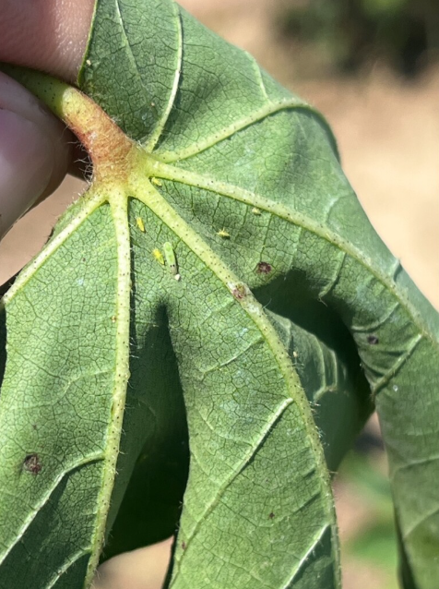

Cotton jassid nymphs (Photo by Hunt Sanders)

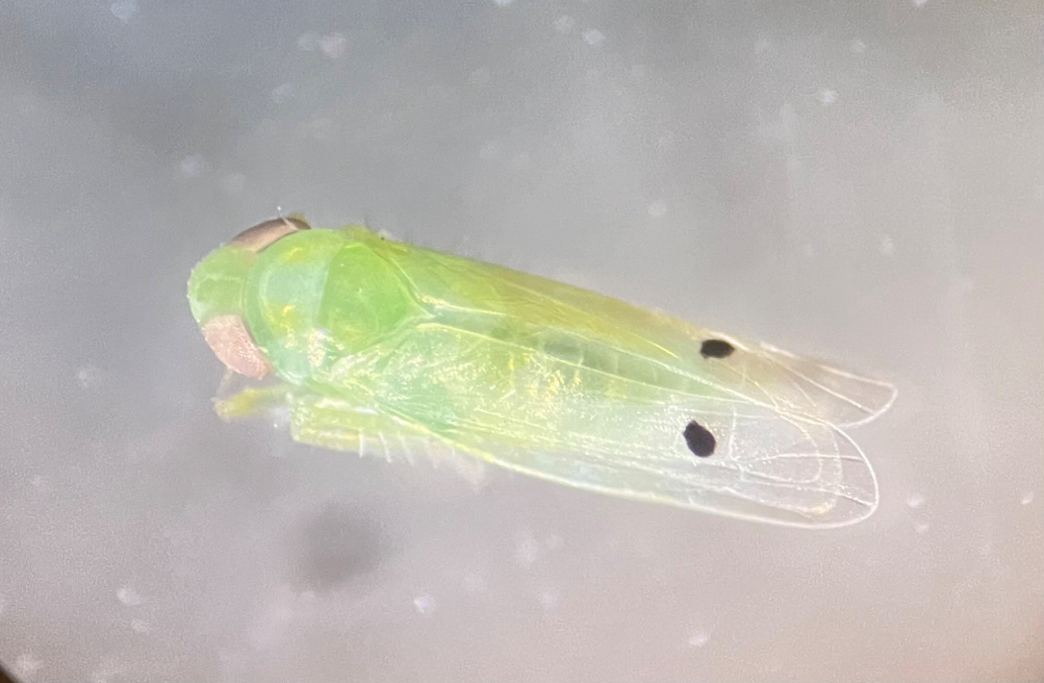

Adult cotton jassid (Photo by Justin Odom)

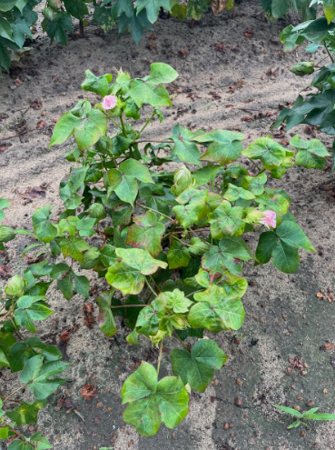

Feeding damage (Photo by Jeremy Kichler)

**Description:**

*Immature stages*: Cotton jassid nymphs are less than 1 mm in length and have oblong light-green bodies. They can be difficult to spot with the naked eye.

*Adult stages*: Adult cotton jassids are about 2-3 mm long and closely resemble the potato leafhopper. They are light-green with a dark spot on each wing and often two dark spots on their heads.

**Biology:**

*Life Cycle:* Female cotton jassids prefer to lay their eggs in the the spongy later of plant tissue between the vascular bundle and the epidermis. Eggs hatch after about 3-4 days. Cotton jassid nymphs undergo five instars over the course of 8-11 days. Once fully grown, an adult will live for 2-4 weeks.

*Distribution:* The cotton jassid is native to the Indian subcontinent. It was observed in Puerto Rico in 2023, and it has since spread, arriving in Florida in 2024. The cotton jassid is believed to have arrived in Georgia in early 2025.

**Damage:**

The cotton jassid's preferred hosts are okra and cotton. The insect feeds on the lower surfaces of leaves, introducing salivary toxins that can cause "leaf puckering." Plants will appear to turn yellow, then red, and finally brown before dying. End plants and field edges experience higher jassid populations.

**Management:**

Count jassid nymphs on the undersides of individual mainstem leaves in the top 6 inches; the preliminary threshold is 1-2 nymphs per leaf. While more data is needed, early trials show success with the following insecticide treatments:

* **Bidrin** has had promising results in commercial fields.
* **Argyle** and **Assail** are not as consistent as Bidren, but are good options in fields where whiteflies are present.
* **Carbine** looks good in small plot trials.

**Source:** Phillip Roberts, University of Georgia, 2025